Features Used

'appetite'

'pedal edema'

'anemia'

'hypertension'

'diabetes mellitus'

'coronary artery disease'

'pus cell clumps'

'age'

'blood pressure'

'serum creatinine'

'blood glucose random'

'sugar', 'hemoglobin'

'sodium'

'potassium'

Random Forest

|  |  |
| --- | --- |
| **hemoglobin** | **0.236** |
| **serum creatinine** | **0.231** |
| **blood glucose random** | **0.149** |
| **hypertension** | **0.145** |
| **sodium** | **0.096** |
| **diabetes mellitus** | **0.040** |
| **blood pressure** | **0.032** |
| **appetite** | **0.029** |
| **pedal edema** | **0.025** |
| **age** | **0.009** |
| **pus cell clumps** | **0.006** |
| **potassium** | **0.003** |
| anemia | 0.000 |
| coronary artery disease | 0.000 |
| sugar | 0.000 |

Training accuracy - 100% Testing accuracy - 100%

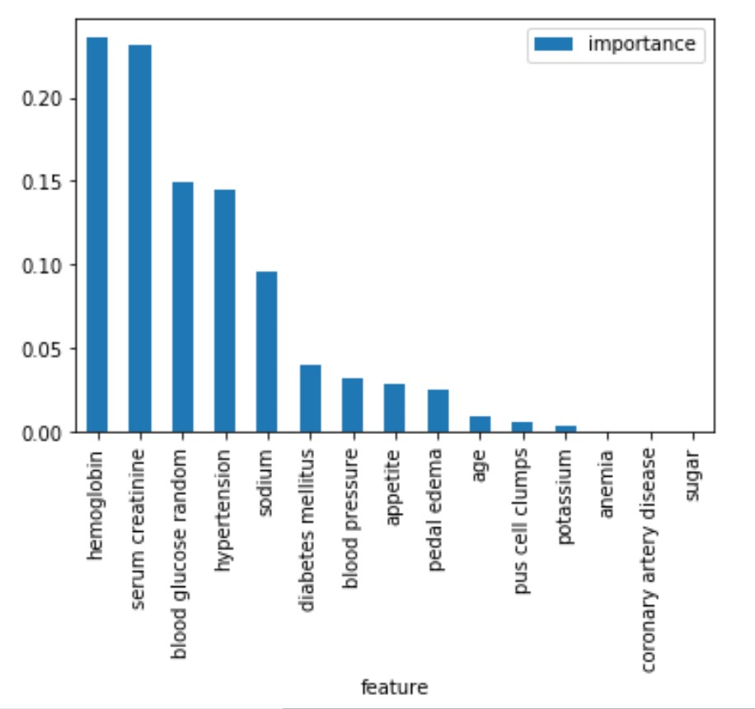Feature Importance

Decision Tree

Training accuracy - 100% Testing accuracy - 100%

Feature Importance

|  |  |
| --- | --- |
| **Serum creatinine** | **0.744** |
| **hemoglobin** | **0.205** |
| **diabetes mellitus** | **0.051** |
| hypertension | 0.000 |
| sodium | 0.000 |
| blood glucose random | 0.000 |
| blood pressure | 0.000 |
| appetite | 0.000 |
| pedal edema | 0.000 |
| age | 0.000 |
| pus cell clumps | 0.000 |
| potassium | 0.000 |
| anemia | 0.000 |
| coronary artery disease | 0.000 |
| sugar | 0.000 |

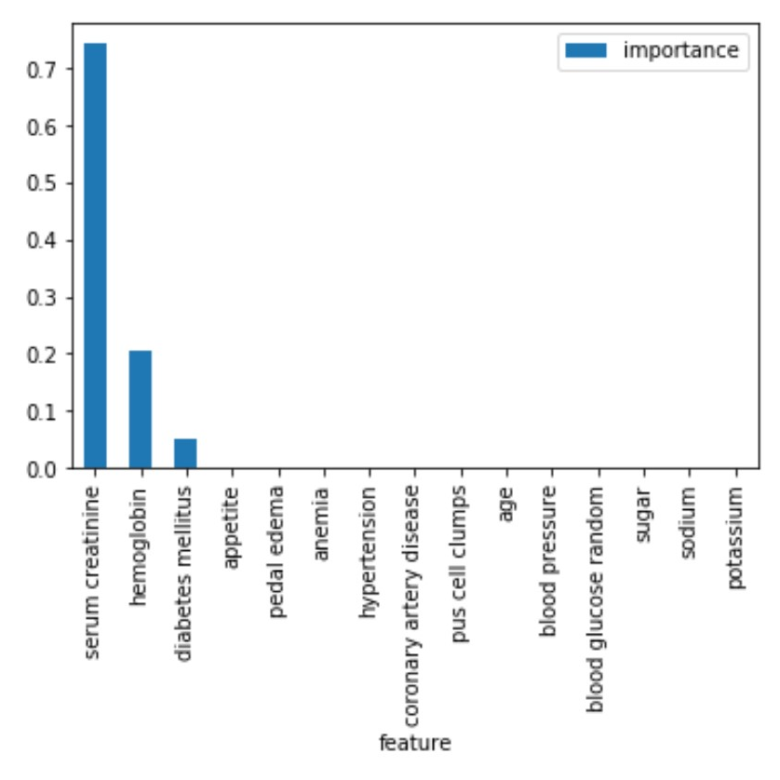

XGB Classifier

Training accuracy – 99.35% Testing accuracy - 100%

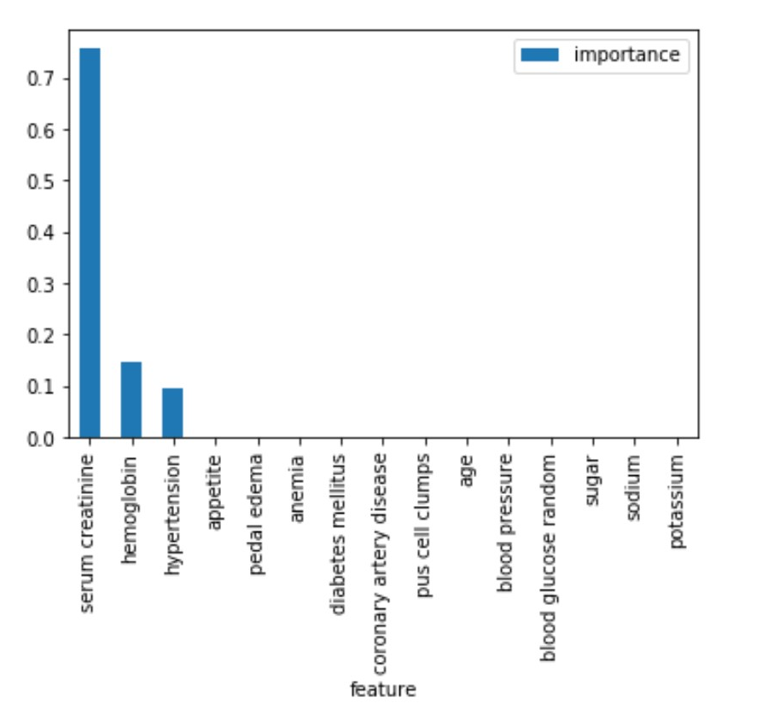

|  |  |
| --- | --- |
| **Serum creatinine** | **0.757** |
| **hemoglobin** | **0.146** |
| **hypertension** | **0.097** |
| diabetes mellitus | 0.000 |
| sodium | 0.000 |
| blood glucose random | 0.000 |
| blood pressure | 0.000 |
| appetite | 0.000 |
| pedal edema | 0.000 |
| age | 0.000 |
| pus cell clumps | 0.000 |
| potassium | 0.000 |
| anemia | 0.000 |
| coronary artery disease | 0.000 |
| sugar | 0.000 |

Logistic Regression

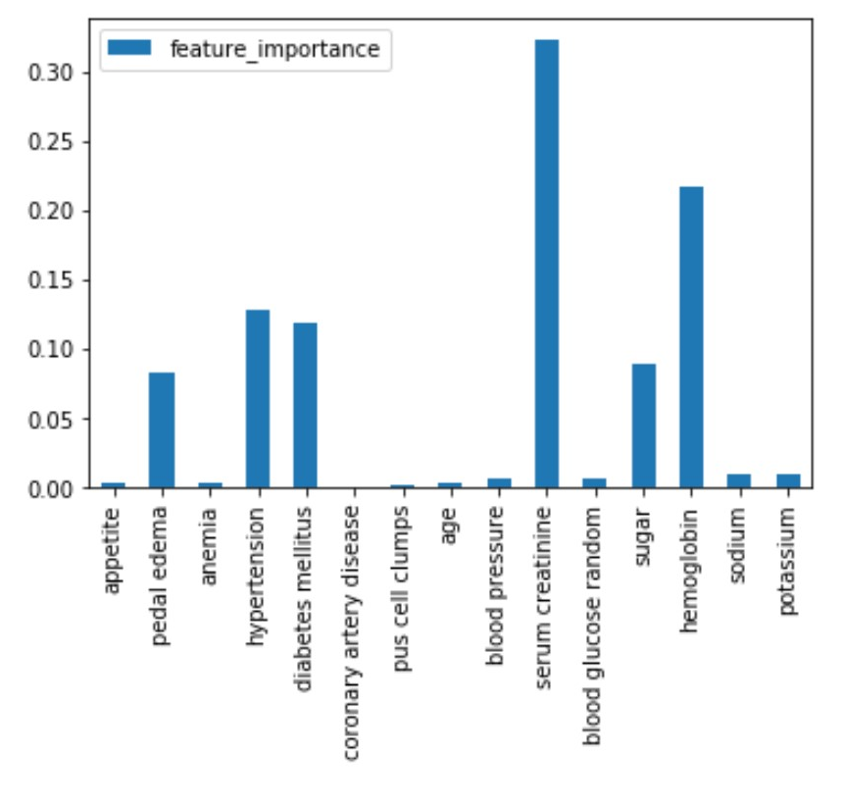Training accuracy – 98.71% Testing accuracy - 100%

|  |  |
| --- | --- |
| Appetite | 0.0034 |
| Pedal edema | 0.0820 |
| Anemia | 0.0025 |
| Hypertension | 0.1284 |
| Diabetes mellitus | 0.1181 |
| coronary artery disease | 0.0002 |
| pus cell clumps | 0.0012 |
| age | 0.0036 |
| Blood pressure | 0.0059 |
| Serum creatinine | 0.3228 |
| Blood glucose random | 0.0063 |
| sugar | 0.0895 |
| Hemoglobin | 0.2161 |
| sodium | 0.0092 |
| potassium | 0.0100 |